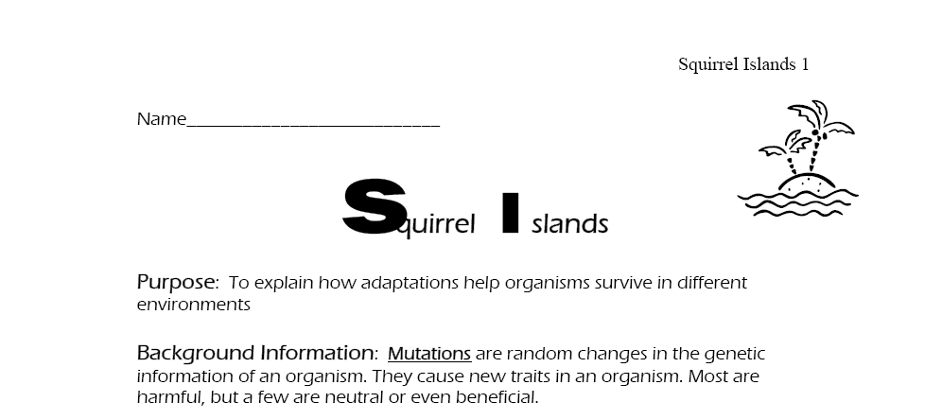

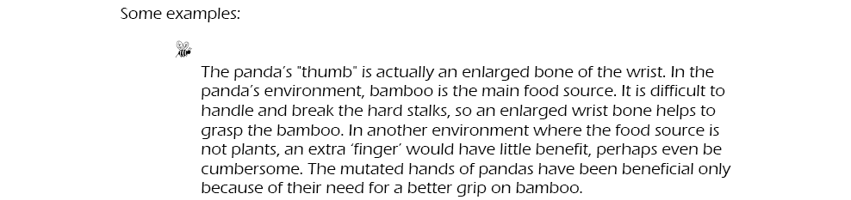
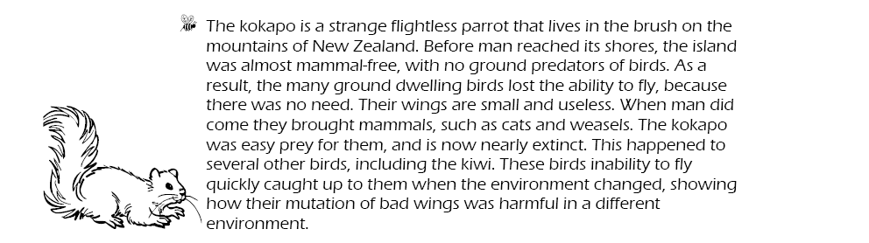
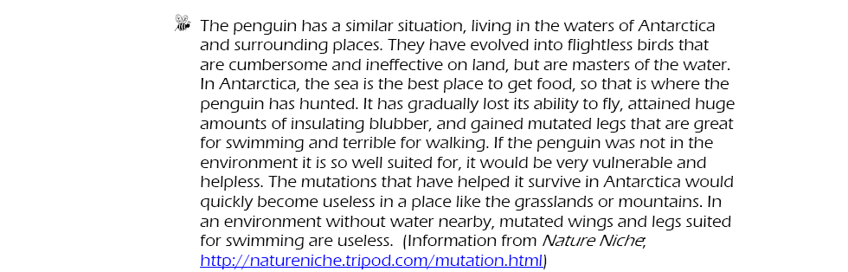

Assignment:

You will be assigned an island habitat. Design a squirrel that has adapted to the environment of the island. It has learned to live within the environment of the island. Over time, its body parts have adapted to the environment. What would that squirrel look like? Draw the island environment and the squirrel. On the back of your drawing, describe the adaptations, and why they are beneficial to the squirrel. Neatness and attention to detail matters!
